**Commodore VIC-20 Diagnostics (Top-Level Project) Rev. 0**

**Module Description**

# Abstract

This is the top-level project of the VIC-20 diagnostic harness and cartridge. The whole diagnostics set consists of:

* A Diagnostic Cartridge
* A User Port PCB
* A Keyboard PCB
* A Cassette Port PCB
* A Cable Set

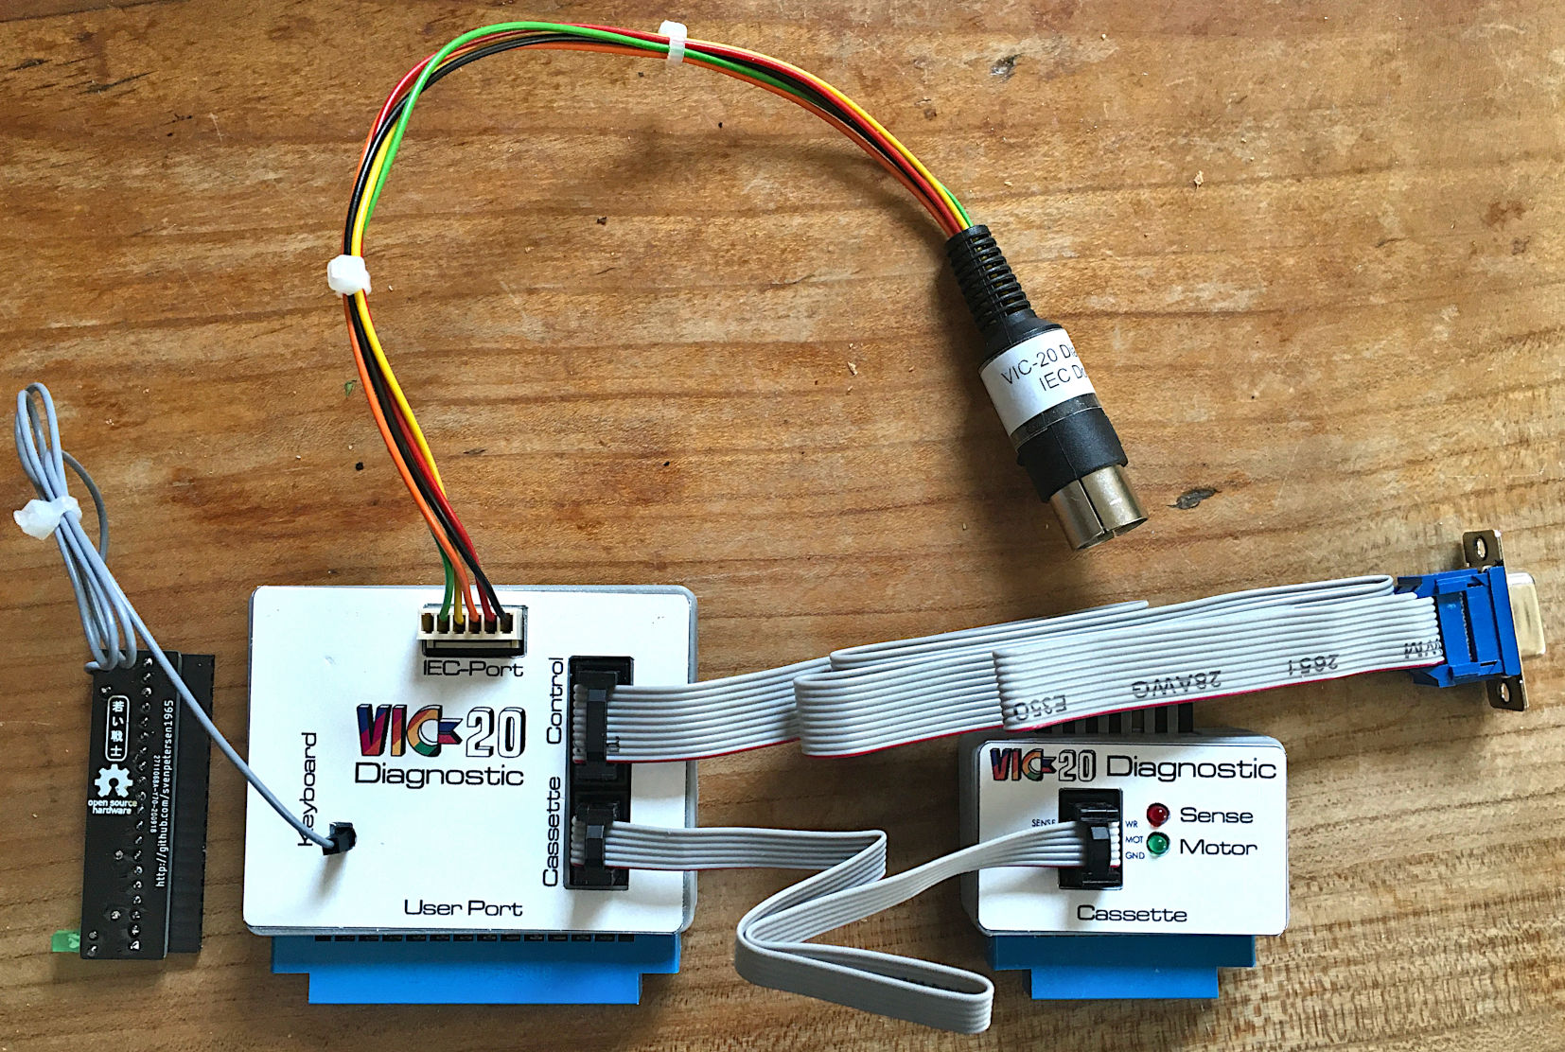

Figure 1: The complete Diagnostic Harness

# Diagnostics Cartridge

The diagnostic cartridge is based on the Super Expander II. It contains the diagnostic software in an EPROM and 1kByte of RAM.

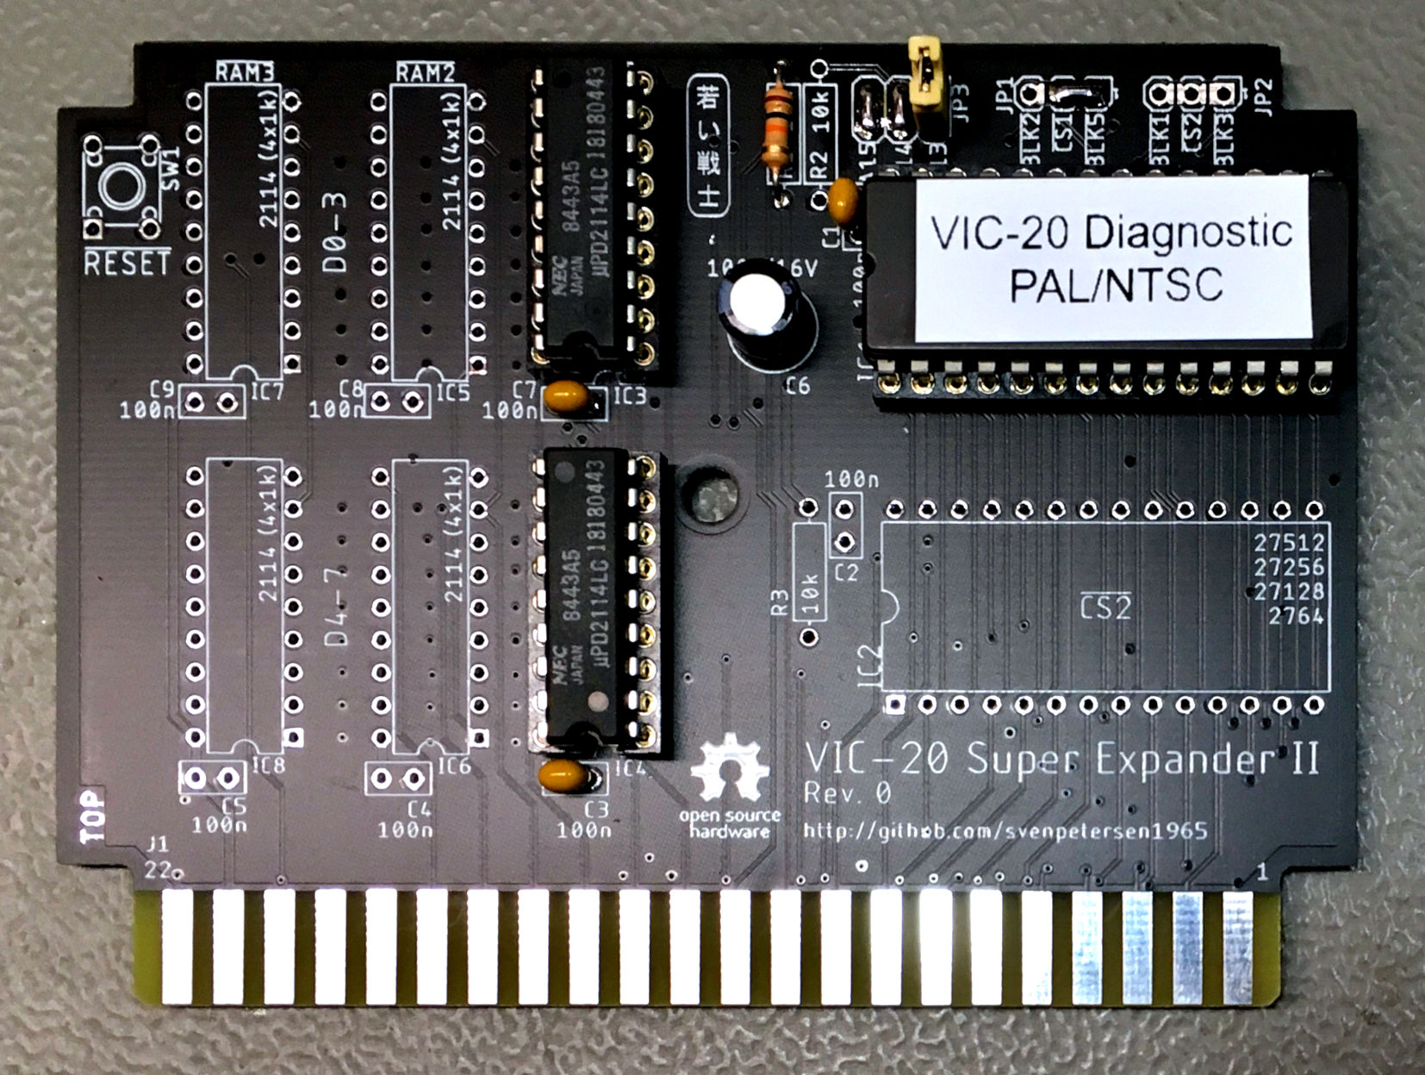

Figure 2: Diagnostics Cartridge

There are two versions of the (original Commodore) test software, which were downloaded from [www.zimmers.net](http://www.zimmers.net/anonftp/pub/cbm/firmware/misc/vc-20diag/index.html). One version is for the PAL VIC-20. It displays “VC-20” (like the name of the computer in Germany). The other version is for NTSC VIC-20 (it displays “VIC-20”).

Both software versions work in the IC1 socket, the chip select hardwired to (the base address is $A000). Thus, the solder bridge at JP1 as seen in Figure 2.

Since there are only two versions of the diagnostic software, two jumpers (A15 and A14) on JP3 can be hardwired (which is valid for a 27C512 EPROM). A 10k for R1 and a single jumper is required to select one of the two software versions.

|  |  |  |
| --- | --- | --- |
| EPROM | Solder bridges closed | Resistors placed |
| 27C512 | A14, A15 | R1 |
| 27C256 | A15 | R1, R2 |
| 27C128 | - | R1, R2, R3 |

The EPROM IC1requires a 100n capacitor in position C1.

The RAM is only 1kByte. That are two 2114 (1kx4) SRAM at position IC3 and IC4 (with 100n at C7 and C3).

The Super Expander II cartridge can be found at github: <https://github.com/svenpetersen1965/Commodore-VIC-20-Super-Expander-II>

# The User Port PCB

The User Port PCB is especially developed for this project. The complete documentation, Gerber data and design files are available on github:

[https://github.com/svenpetersen1965/VIC-20_Diagnostics](https://github.com/svenpetersen1965)

A 3D printable case is provided in the same repository.

# The Keyboard PCB

The Keyboard PCB is especially developed for this project. The complete documentation, Gerber data and design files are available on github:

[https://github.com/svenpetersen1965/VIC-20_Diagnostics](https://github.com/svenpetersen1965)

# The Cassette Port PCB

The Cassette Port PCB is identical to the Cassette Port PCB of the C64 Diagnostic harness. It is available from github:

<https://github.com/svenpetersen1965/C64-Diagnostic-Rev.-586220-Harness>

A 3D printable case can be found in the same repository.

All required feedbacks are realized on the User Port PCB, which connects to the Cassette Port PCB via a ribbon cable. The cassette port PCB is free of any typical feedbacks. Two signals are indicated with LEDs.

# The Cable Set

The cable set consists of four cables:

* The IEC Port Cable
* The Control Port Cable
* The Cassette Port Cable
* The Keyboard RESTORE cable

The Control Port cable and the Cassette Port cable are identical to the C64 Diagnostic Harness cables.

The IEC-Port cable connects the IEC port to the User Port PCB, which provides the required feed backs.

The RESTORE cable connects the Keyboard PCB to the User Port PCB. This is a simple DuPont wire, which is soldered to the Keyboard PCB on one side.

The documentation for the Cable Set can be found on github:

[https://github.com/svenpetersen1965/VIC-20_Diagnostics](https://github.com/svenpetersen1965)